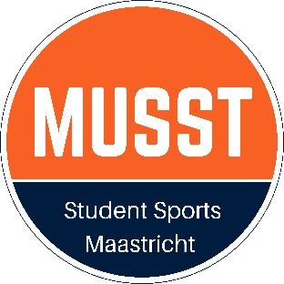
Request form for SSA
Event Subsidy

This form can be used by Student Sport Associations affliated with Sports Council MUSST.
Send this form to MUSST 3 weeks before the event subscriptions open. Then follow up steps will take place.

Name SSA:
Event: | Date event:
Contact persons:

Event purpose:

Short event description:

Can other people than your members join the event? Yes/No

Is MUSST mentioned on your promotion materials? Yes/No

Does the budget plan show that profit is being made? Yes/No
Attach tot his file:
- A budget plan.
- Your availability for a meeting with the MUSST treasurer
Date: | Signature:
Only complete requests, with attachements, will be taken into account.
Please send requests to MUSST 3 weeks before the event subscriptions open.

